# Publishing Settings for Captivate

### SCORM Publish Settings

SCORM publish settings are required for upload and progress tracking in JADL ILIAS Learning Management System.

1. In Captivate, select File > Publishing Settings…
2. Under ‘Quiz’ section, select ‘Reporting’
   1. Check ‘Enable reporting for this project’
   2. In the ‘LMS’ dropdown, select ‘Other Standard LMSs’
   3. In the ‘Standard’ dropdown, select ‘SCORM 1.2’ (best compatibility option for ILIAS)
   4. Next to ‘Standard’, select ‘Configure’ button
      1. Provide ‘Course Identifier’ (no spaces or special characters, ex: ADL213)
      2. Provide ‘Course lesson Title’
      3. Provide ‘SCO Identifier’ (no spaces or special characters, ex: ADL2130101)
      4. Provide ‘SCO Title’
      5. Select ‘OK’ to close windows
   5. In the ‘Template’ dropdown, select ‘Default’
   6. Under ‘Status Representation’, select ‘Incomplete 🡪 Complete’
   7. Under ‘Success/Completion Criteria’, select ‘Slide views and/or quiz’
      1. If there is NO assessment for the SCO, select ‘Slide views’, ‘100%’
      2. If there is a graded assessment, select ‘Quiz’, ‘Quiz Passed’
   8. Under ‘Data To Report’, select ‘Percentage’
   9. Leave ‘Interaction Data’ checked
   10. Under ‘LMS Initialization Text’, enter ‘Loading’
   11. Select the ‘Advanced’ button
       1. Check ‘Send Resume Data’
       2. Check ‘Set exit to normal after completion’
       3. Check ‘Escape Version and Session ID’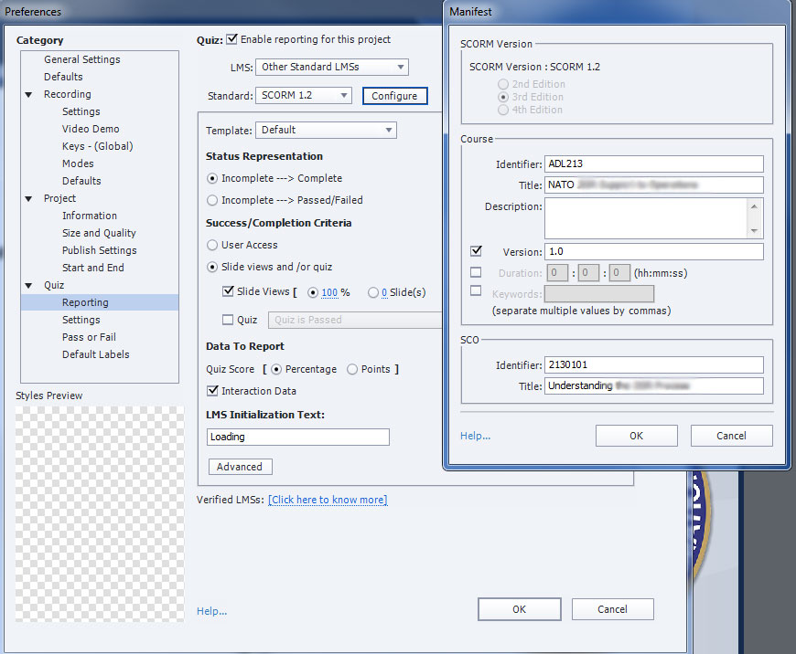Select ‘OK’
3. Under ‘Quiz’ section, select the ‘Settings’ menu
   1. Provide unique ‘Objective ID’ identifier (ex: QuizADL2130101)
   2. Check ‘Allow Backward Movement’
4. Under ‘Quiz’ section, select ‘Pass or Fail’
   1. For pass/fail options, recommend ‘80’ % or more of total points to pass
   2. Check ‘Show Retake Button’

### Quality Publishing Settings

1. In Captivate, select File > Publish Settings…
2. Under ‘Project’ section, select ‘Size and Quality’
   1. Uncheck ‘Retain Slide Quality Settings’
   2. In the ‘Bmp’ dropdown, set to ‘High (24 bit)’
   3. Check ‘Advanced Project Compression’
   4. Check ‘Compress SWF File’

### Final project publishing

1. In Captivate, Select File > Publish…
2. In the ‘Publish’ dropdown, select ‘HTML5/SWF’
3. Provide a ‘Project Title’ (no special characters or spaces ex: 2130101)
4. Provide a ‘Location’ path
5. Check ‘Zip Files’
6. Under ‘Output Format’, select only ‘HTML5’ buttons
7. Uncheck all other options
8. Select the ‘Publish’ button 